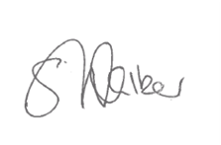

or visit <https://bit.ly/3Vfk6cZ>

If you are a carer, please find out what help you can get by contacting:

**Email:** [bnssg.hospitalcarerliaisonservice@nhs.net](mailto:bnssg.hospitalcarerliaisonservice@nhs.net)  or [hospitalteam@alliancehomes.org.uk](mailto:hospitalteam@alliancehomes.org.uk) **Telephone:** 0117 937 5629 (NBT) 0117 4350188 (BRI) 01934 636363 and ask for Ex 3193 (Weston)

**Carers and Young Carers Charter**

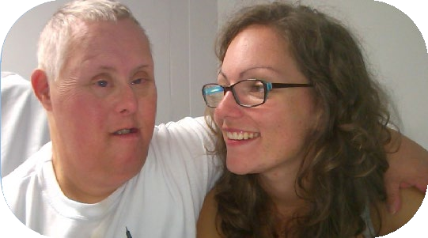

Promoting a culture of supporting and

working in partnership with carers within

our hospitals.

For more information, scan the QR Code.

**Our Pledge**

**Carers as**

**equal**

**Supporting carers**

**Young**

**carers**

**partners**

**Having a**

**voice**

**Sharing**

**information**

**Discharge**

**planning**



**Stuart Walker**

Chief Executive, UHBW

**Deirdre Fowler**

Chief Nurse and Midwife, UHBW

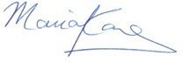

**Maria Kane**

Chief Executive, NBT

**Steve Hams**

Chief Nursing Officer, NBT

