**Give as you live directions**

Go to our website (<https://www.carerssupportcentre.org.uk/>) and click the “Support us” tab at the top.



Select “Online Shopping”

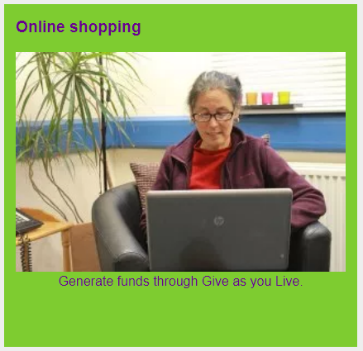

Select “Give as you Live page” in the text. This will take you to the Give as you Live page.

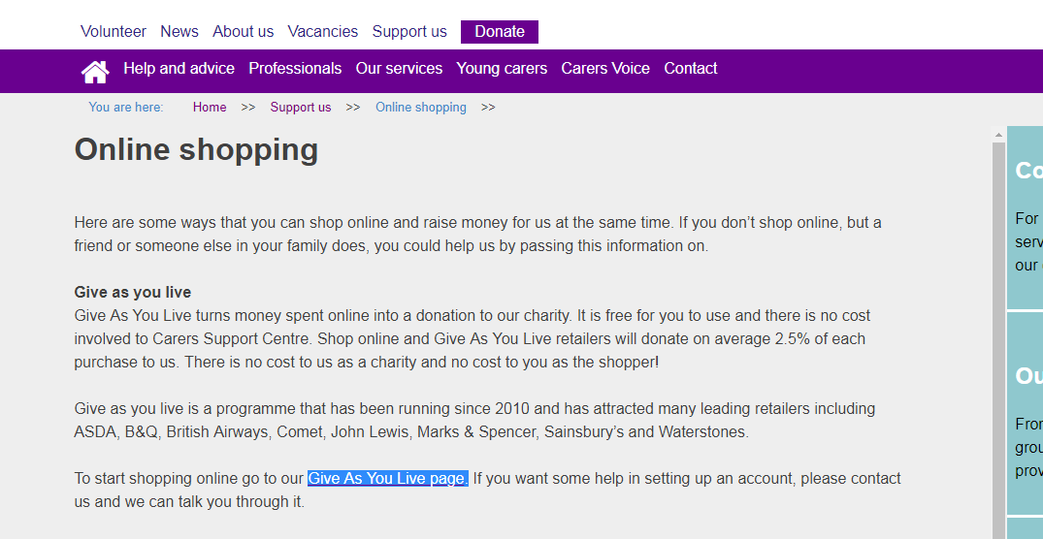

Scroll down on the Give as you live homepage until you see “Get Started”

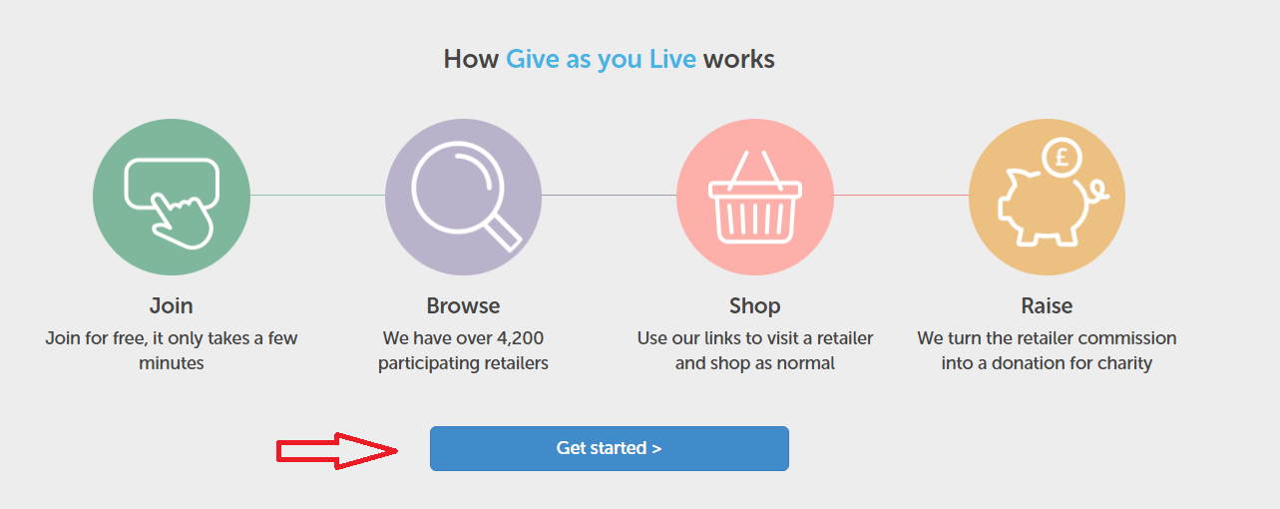

Enter our charity name and search, click on the one with our logo when it comes up

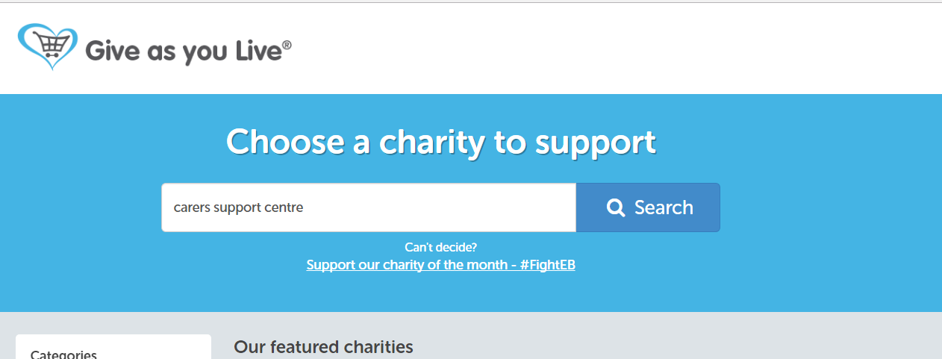

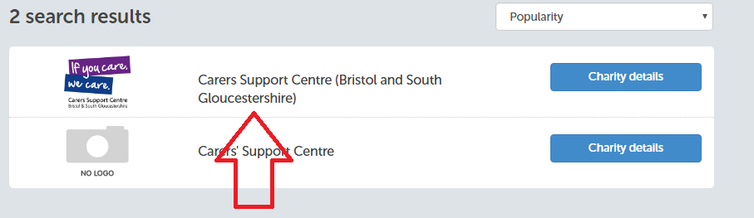

Select “support this charity”



Sign up by entering your name, email and a password that you have created (or log in via facebook)

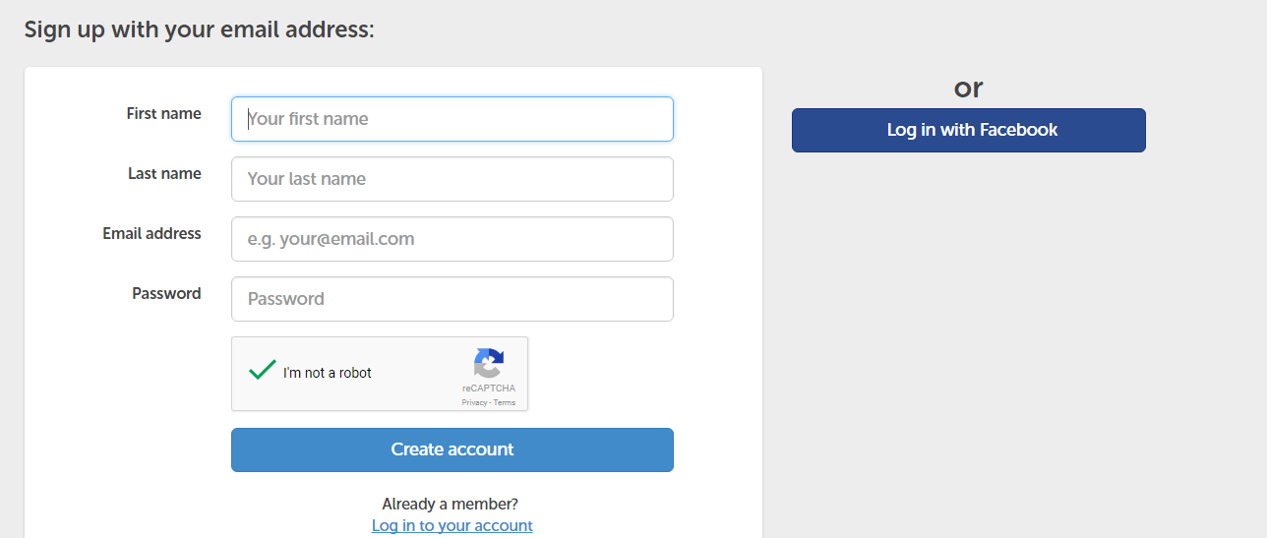

You are now signed up to support us via Give as you Live. You can at this stage select your favourite retailers, or at the next page have a tour of the website.